*Operating Systems 1004*

# A brief introduction to the file system in the Harmony operating system

*Prepared by*

陈玙涛 1930026016

薛劭杰 1930026143

古薇 1930026036

Content

A brief introduction to the file system in the Harmony operating system 1

Introduction 2

The file system of the Harmony operating system 4

Virtual file system(VFS) in Harmony OS 4

Harmony distributed file service 5

Conclusion 8

Reference 8

## Introduction

HarmonyOS (Chinese: 鸿蒙; pinyin: Hóngméng), was created by Huawei Technologies Co., Ltd. at the Huawei developer conference held in Dongguan on August 9, 2019. The mission of HarmonyOS is to collaborate and interconnect with multiple smart devices. In addition, to prevent the US from prohibiting Huawei from using Android on future smartphone products, in the background of the “China-United States Trade War” and “Entity List”. Apart from this, HarmonyOS could help make full use of Huawei’s strength in the equipment for Fifth-generation (5G) wireless communication, data could be shared more efficiently between hardware electronics devices and IoT applications by using 5G Hilink.

HarmonyOS is an innovative, distributed operating system for the Internet of Everything (IoE) era. It could run on IoT devices(LiteOS kernel), Smartphones and tablets(Linux kernel layer with AOSP libraries), and Smart home devices.

As early as 2012, Huawei began planning its own HarmonyOS. On May 17, 2019, the Huawei OS team led by Ren Zhengfei developed HarmonyOS, an operating system with independent property rights. On August 9 of the same year, Huawei officially released the HarmonyOS. At the same time, Yu Chengdong said that HarmonyOS was open source. This means that Huawei officially entered the infrastructure part of information technology. Huawei hopes to cooperate with all Chinese and even foreign companies to build this IoT operating system.

Nowadays, there are over 150 million users in China using HarmonyOS. Because HarmonyOS could help china blunt the attack from the US chip and software ban.

The distinguishing part of HarmonyOS is using a multi-kernel design so that appropriate OS kernels can be selected for devices with different resource limitations. And HarmonyOS is a next-gen operating system that can run on a wide range of smart devices. It enables different smart devices to speak the same language, facilitating better connection and collaboration and bringing a simple, smooth, continuous, secure, and reliable interaction experience in all scenarios.

The traditional system is like a fixed toy model, which is only applicable to fixed terminal devices, while Harmony is like a building block that can be combined and assembled into various types of device terminals. It is more suitable for terminal devices in the IoT era than system designs such as Android and IOS. Its system functions can be customized to run on multiple end devices with different hardware configurations. Traditional systems, such as Apple, develop and maintain three different systems for cell phones (IOS), computers (Mac OS), and watches (watch OS), which are independent of each other. The Harmony system maintains one and provides services to applications through the core capabilities of the system service layer. Depending on the deployment environment of different device forms, the set of base software service subsystems, the set of enhanced software service subsystems, and the set of hardware service subsystems can be trimmed according to subsystem granularity, and each subsystem can be trimmed internally.

There are three features of HarmonyOS that are new.

The first is hardware collaboration and resource sharing. HarmonyOS could provide flexible expansion of different device hardware capabilities by aggregating all the devices running on the HarmonyOS at the system level and combining them as a super device. Under the conditions mentioned above, users can integrate the capabilities of all devices to achieve ultra-fast connectivity, capability collaboration, and resource sharing. In this way, services can be seamlessly transferred to the most appropriate devices, providing a smooth full-scene experience.

The second is one-time development for multi-device deployment. The developers could focus more on the upper layer service logic to develop applications, the HaymonyOS could help developers deploy their applications to a variety of devices by using its distributed technology.

The third is unified OS for flexible deployment. On-demand deployment of devices is used at HarmonyOS, different devices could have different capabilities by using the component-based design of HarmonyOS, which means depending on respective resource capabilities and service characteristics HarmonyOS could provide tailored service to any specific device form.

## The file system of the Harmony operating system

### Virtual file system(VFS) in Harmony OS

Harmony system can support mutual access, sharing and operation of files between multiple devices. Additionally, the application can sense the storage device where the file is located, and seamlessly obtaining the file between multiple devices. These functions are largely benefited from the services of the Harmony distributed file system.

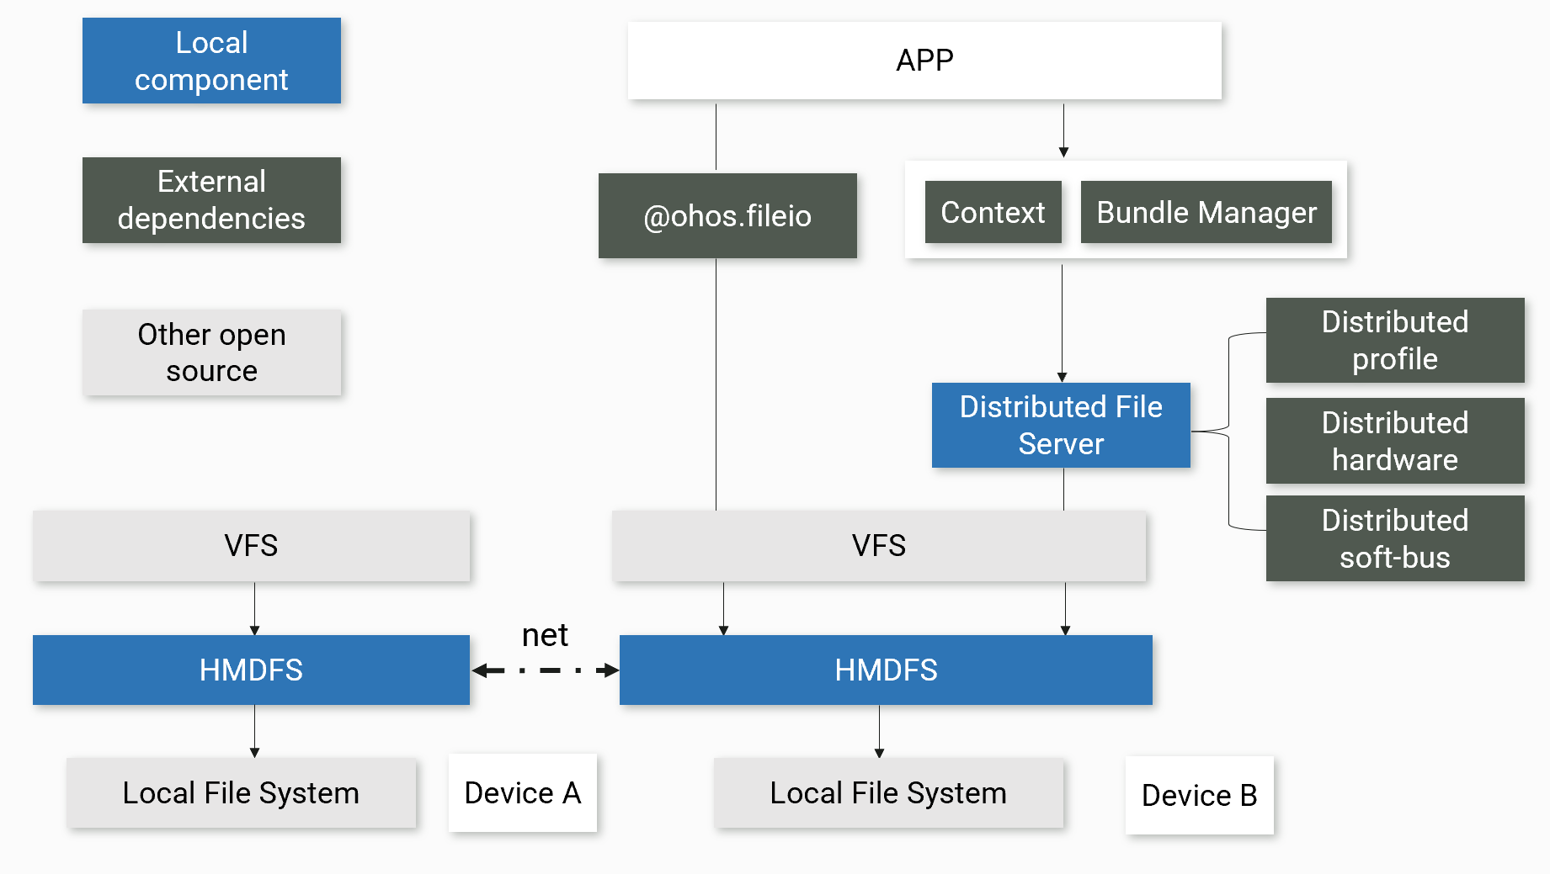

VFS (Virtual File System) is the virtual layer of the file system, providing users with a unified Unix-like file operation interface. Since the interfaces of different types of file systems are not uniform, if there are multiple file system types in the system, different non-standard interfaces need to be used to access different file systems. By adding a VFS layer to the system to provide a unified abstract interface, the differences between the underlying heterogeneous file systems are shielded, so that the system calls that access the file system do not need to care about the underlying file system type. In this way, different file systems on different devices appear identical to the HarmonyOS core and other processes running in the system.

User processes access the Linux VFS using system calls from the VFS user interface. The VFS layer then distributes the unified calls to the different file systems for the underlying operations in the form of function pointers for the different file system types. The respective implementations of each file system include interfaces for mount related operations, interfaces for mapping file system types and interfaces for file system operations. Take windows OS as an example, we use the VFS system call to get the NTFS file system mapped to Windows, and then use the Windows file system call to make some requests such read and write to the Windows file system.

For mobile devices that support HarmonyOS, the file systems include F2FS, EROFS (new mobile phones and tablets). VFS plays an indispensable role to access different file systems easily between PC and mobile or even other storage devices. On the other hand, it also need the HMDFS (harmony distributed files system) as intermediate of different file system to perform distributed operation permission control.

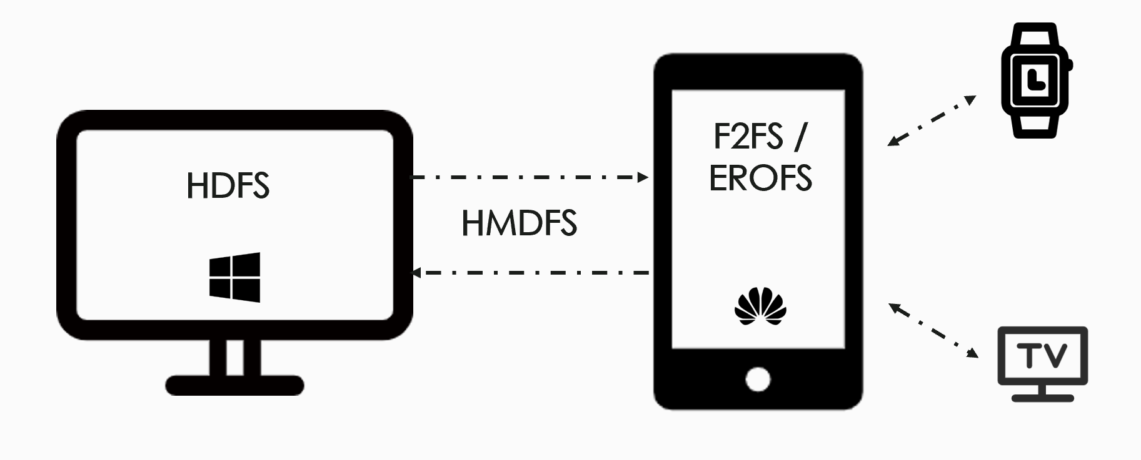

The application of HarmonyOS consists of one or more FA (Feature Ability) or PA (Particle Ability). Among them, FA has UI interface and provides the ability to interact with users, while PA has no UI interface and only provides the ability to run tasks in the background and a unified data access abstraction. And here is an example for mobile and PC file interaction.

### Harmony distributed file service

The premise of seamless file access between multiple devices is that in a distributed endpoint scenario, the devices used by users and the user files in the virtual endpoint are secure and reliable. After two or more devices establish a secure connection and build a virtual file system, the harmony distributed file service can help users obtain files between multiple devices seamlessly. This function is mainly concerned with file organization and access, file transfer and file storage.

Users and applications view files as some kind of structure with organized records, such as a sequential structure. In order to convert user commands into specific file operation instructions, an access method appropriate to that file structure must be used.

When choosing a file organization, quick access, ease of modification, storage space savings, simplicity of maintenance, and reliability are the first five factors we consider. However, sometimes these principles can be contradictory. For example, to save storage space, data redundancy should be minimal; but redundancy is an important means of increasing access speed.

Ability is an abstraction of an application's capabilities and is an important part of the application. HarmonyOS supports the deployment of applications in Ability units. Ability can be divided into two types: FA (Feature Ability) and PA (Particle Ability). JS FA refers to applications based on JavaScript or JavaScript and Java hybrid development FA.

The number of file organizations is quite large, but most of them are based on heaps, sequential files, indexed sequential files, indexed files, direct or hash files. a typical development directory structure of a JS module (entry/src/main/js/module) for a JS FA application is as follows:

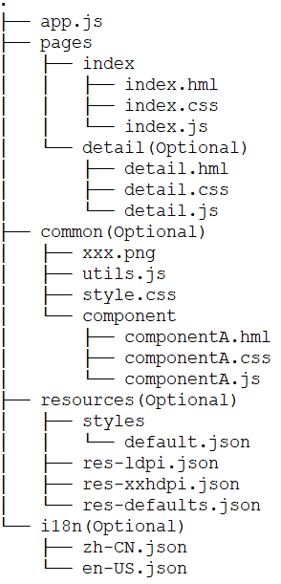

The application's resource files, such as strings, images, audio, etc., are stored in the resources directory in a unified manner to facilitate developers' use and maintenance. resources directory includes two major categories of directories, one for base and qualifier directories, and the other for rawfile directories. base and qualifier directories are organized in a two-level directory format, and file naming needs to The rawfile directory supports the creation of multiple subdirectories with customizable names and the free placement of various resource files in the folders. In addition, the files in the rawfile directory do not match different resources according to the device status. base and qualifier directories refer to resource files by a combination of file type (type) and resource name (name). The rawfile directory can be referenced by specifying a file path and a file name. Compared to traditional file organization methods, Harmony's JS FA application builds such a file organization that may reduce the conflict between data redundancy and fast access.

In order to ensure the secure flow of data between virtual super terminals, it is required that each device is correctly trusted and has established a trust relationship, which means that multiple devices establish a pairing relationship through Huawei accounts and can establish a secure connection channel after verifying the trust relationship, and transmit data securely according to the rules of data flow. When devices communicate with each other, they need to be authenticated based on the identity credentials of the devices, and based on this, a secure encrypted transmission channel is established.

HarmonyOS is a distributed operating system for full scenarios with a component-based design that requires system components to be run on devices with different configurations. To this end, Harmony OS defines three base system types for device developers to choose from and complete the base configuration for minimal system development. The three base types are Mini, Small and Standard.

Mini systems are geared toward MCU-like processors, such as RISC-V 32-bit devices. These devices have extremely limited hardware resources, with a minimum memory of 128 KiB, and can support products such as wearable smart devices and sensor devices.

Small systems oriented application processors, such as Arm Cortex-A devices, support devices with a minimum memory of 1MiB, which can improve the security of the system and its image framework, etc. Products that can be supported include electronic cat eyes, routers, car recorders in the field of smart travel, etc.

Standard system is for devices with application processors such as Arm Cortex-A, and supports devices with a minimum memory of 128MiB, providing users with greater interaction capabilities, 3D GPU and hardware synthesis. Supported products include high-end refrigerator displays.

The lightweight kernel supports multiple file systems such as FAT, JFFS2, NFS, ramfs, procfs, etc., and provides a complete POSIX standard operating interface to the outside world; internally, it uses the VFS layer as a unified adaptation layer framework to facilitate the porting of new file systems, and each file system can automatically take advantage of the rich features provided by the VFS layer.

JFFS2 stands for Journalling Flash File System Version 2, which is a journalling type file system implemented on MTD devices. JFFS2 is mainly used in NOR FLASH and features read/write, data compression, crash/power down security, "write balance" support, etc.

Harmony OS introduces the Little file system, which is a small Flash file system(JFFS2) that combines the ideas of log-structured file system (LFS) and COW (copy-on-write) file system, storing file metadata in a log structure and data in a COW structure.

As we know, file metadata is the data used to characterize files, containing information such as file name, file size, creation, access, modification time, etc. One of the motivations for LFS is to minimize the conflict between the exponential growth in processor speed and main memory size and the slower development of disk access costs. LFS focuses on write performance, utilizing sequential bandwidth, and on disk writes and file metadata updates work efficiently.

COW is a resource management technique that can be used to implement fork system calls that share the virtual memory (pages) of the operating system. When a written request is made, the data are copied into a new storage area. Then, the original data are modified. One of the reasons Harmony OS introduced COW is that it is so space efficient that its reserved snapshot storage space only needs to be large enough to capture the changed data.

This special storage method gives LittleFS a powerful power-loss resilience designed to handle random power failures. All file operations have strong write-time copy guarantees, and if power is lost, the file system will revert to its last known good state. LittleFS uses a dynamic loss equalization algorithm called statistical loss equalization when allocating COW data blocks, so that the lifetime of Flash devices is effectively guaranteed. LittleFS is also designed for small, resource-constrained devices with extremely limited ROM and RAM footprint, and all RAM usage is allocated through a configurable fixed-size buffer that does not take up more system resources as the file system expands. LittleFS is a good choice when looking for a Flash file system with power-down recovery and support for wear-leveling on a small device with very tight resources.

## Conclusion

Harmony OS is a new distributed operating system for all scenarios, which is evolving towards the Internet of Everything.

Harmony OS's Distributed File Service provides file sharing capabilities for different devices that are logged into the same Huawei account and are under the same network. The VFS layer assigns uniform calls to different file systems for basic operations in the form of function pointers for different file system types. With the help of VFS, applications can provide users with seamless file transfers without being aware of the smart device where the files are located.

Harmony Distributed File Service takes into account the storage characteristics of different devices and strives to develop different high-performance storage solutions for different devices. Our group introduced the device and its storage features using Little OS as an example of a lightweight system.

Finally, as Harmony OS is still evolving, some of the enterprise features of its file system are bound to be consumerized. The file system will also move towards higher space utilization, more security, support for deletion of redundancy, compression and cloning, etc.

## Reference

[1]“About HarmonyOS-HarmonyOS Overview-Introduction-HarmonyOSDeveloper.” *HarmonyOS Developer*, https://developer.harmonyos.com/en/docs/documentation/doc-guides/harmonyos-overview-0000000000011903. Accessed 5 June 2022.

[2]“HarmonyOS.” *Wikipedia*, https://en.wikipedia.org/wiki/HarmonyOS. Accessed 5 June 2022.

[3]“HarmonyOS 2 - Huawei Global.” *HUAWEI Consumer*, https://consumer.huawei.com/en/harmonyos/.

Accessed 5 June 2022.

[4]“HarmonyOS 'is a success', embedded to 150 million devices, appliances: Huawei.” *Global Times*, 23 October 2021, https://www.globaltimes.cn/page/202110/1237087.shtml. Accessed 5 June 2022.

[5]“Harmony light kernel M source code analysis - virtual file system VFS” https://bbs.huaweicloud.com/blogs/326407. Accessed 14 January 2022

[6]Stallings, W. (1998). *Operating systems internals and design principles*. Prentice-Hall, Inc..

[7]HarmonyOS All rights reserved ©2022. (n.d.). *Distributed File Service Overview*. docoment center. Retrieved June 6, 2022, from https://developer.harmonyos.com/cn/docs/documentation/doc-guides/database-dfs-overview-0000000000030154